**Contents**

* What is DevOps?
* Roles of Development and Operation Team
* Software Development Life Cycle (SDLC)
  + Waterfall
  + Agile Methodology
* Tools going to Learn in DevOps

**Developer Team**

* Develop Applications
* Collaborate with other Developers in Team
* Maintain Source Code Repos
* Pass on the code to the operations team

**Operations Team**

* Provide the required Infrastructure
* Deploy the Application and Database.
* Monitor application

**Software Development Life Cycle**

* SDLC describes developing process of software to fulfill the client requirements.
* Popular SDLC models:
  + Waterfall Model
  + Agile Methodology

**Waterfall Model**

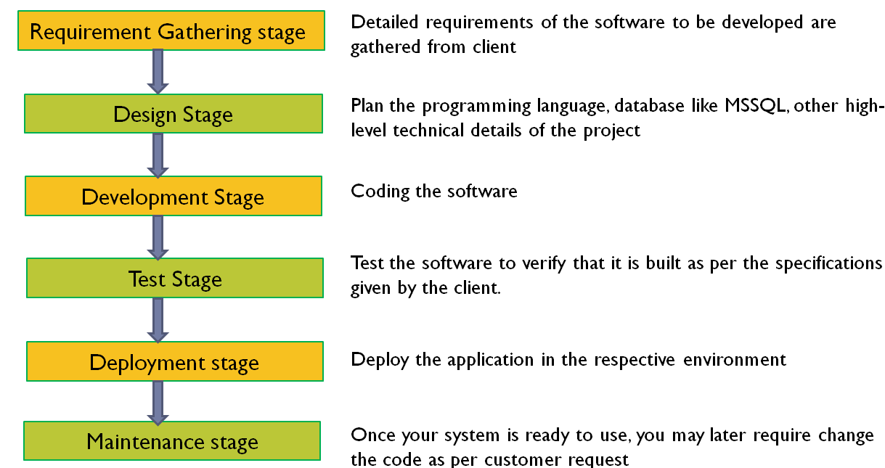

**Drawback of Waterfall Model**

* Hard to accurately define requirements, which can change over time. After delivery requires change requests and additional cost.
* Lack of a communication between teams.

**Agile Methodology**

* Agile is a process that breaks a project into several phases.
* Development methods are based on iterations.
* At the end of each iteration, there should be tested working software.

**DevOps (Development + Operation)**

* DevOps is a culture that emphasizes using of various automation tools for collaboration and communication of both software developers and other professionals.

**Tools**

1. Git
2. Bitbucket
3. Azure Repo
4. Confluence
5. Jenkins
6. Docker
7. Kubernetes
8. Jira
9. Azure Wiki
10. Azure Board
11. Azure Build Pipeline
12. Azure Release Pipeline